**VISVESVARAYA TECHNOLOGICAL UNIVERSITY**

**“JnanaSangama”, Belgaum -590014, Karnataka.**



**LAB REPORT**

**on**

**Object Oriented Modeling and Design**

*Submitted by*

**Piyush Dubey (1BM19CS221)**

***in partial fulfillment for the award of the degree of***

**BACHELOR OF ENGINEERING**

***in***

**COMPUTER SCIENCE AND ENGINEERING**



**B.M.S. COLLEGE OF ENGINEERING**

**(Autonomous Institution under VTU)**

**BENGALURU-560019**

**May-2022 to July-2022**

**B. M. S. College of Engineering,**

**Bull Temple Road, Bangalore 560019**

(Affiliated To Visvesvaraya Technological University, Belgaum)

**Department of Computer Science and Engineering**



**CERTIFICATE**

This is to certify that the Lab work entitled “**Object Oriented Modeling and Design**” carried out by Piyush Dubey**(1BM19CS221),** who is a bonafide student of **B. M. S. College of Engineering.** It is in partial fulfillment for the award of **Bachelor of Engineering in Computer Science and Engineering** of the Visvesvaraya Technological University, Belgaum during the year 2022. The Lab report has been approved as it satisfies the academic requirements in respect of a "**Object Oriented Modeling and Design**"**- (20CS6PCOMD)** work prescribed for the said degree.

**Dr. Shyamala G.**              **Dr. Jyothi S Nayak**

Assistant Professor Professor and Head

Department of CSE Department of CSE

BMSCE, Bengaluru BMSCE, Bengaluru

`

**Index Sheet**

|  |  |  |
| --- | --- | --- |
| **Sl.**  **No.** | **Experiment Title** | **Page No.** |
| **1)** | **College Information System** | **1-2** |
| **2)** | **Hostel Management System** | **3-4** |
| **3)** | **Stock Maintenance System** | **5-6** |
| **4)** | **Coffee Vending Machine** | **7-8** |
| **5)** | **Online Shopping System** | **9-10** |
| **6)** | **Railway Reservation System** | **11-12** |
| **7)** | **Graphics Editor** | **13-14** |

**Course Outcome**

|  |  |
| --- | --- |
| **CO1** | Ability to apply the knowledge of class, State & Interaction Modeling using Unified Modeling Language to solve a given problem. |
| **CO2** | Ability to analyze a System for a given requirement using Unified Modeling language. |
| **CO3** | Ability to design a given system using high level strategy. |
| **CO4** | Ability to conduct practical experiment to solve a given problem using Unified Modeling language. |

**1. COLLEGE INFORMATION SYSTEM**

Advanced Class Diagram :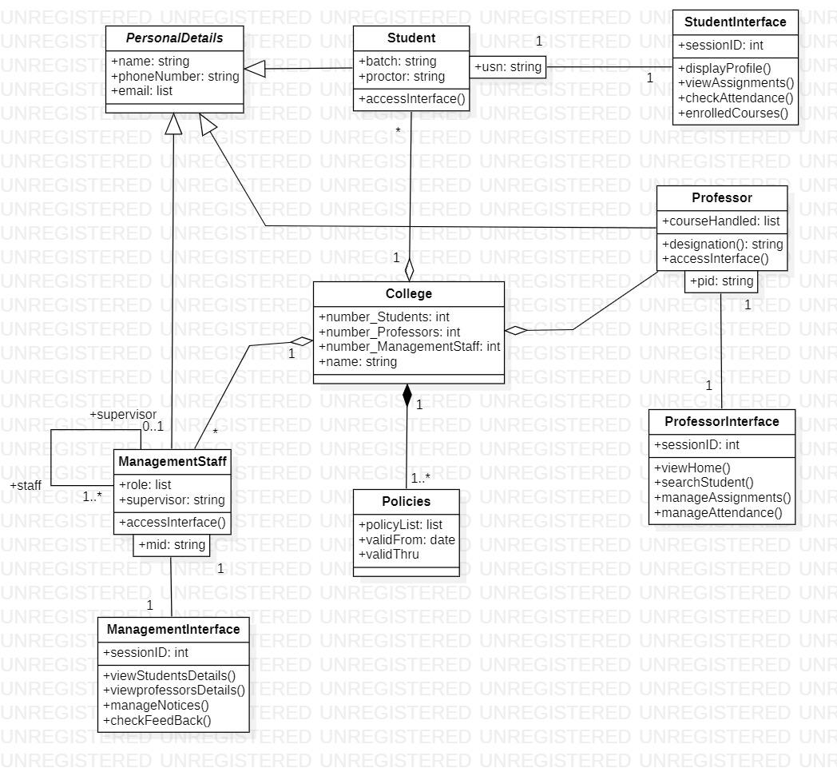

In the above class model, there is composition which shows that without college, there won't be any policies but aggregation between college and professor show that professors are part of college but can exist without college also. Generalization is also used in personal details which have many subforms.

Advance State Diagram: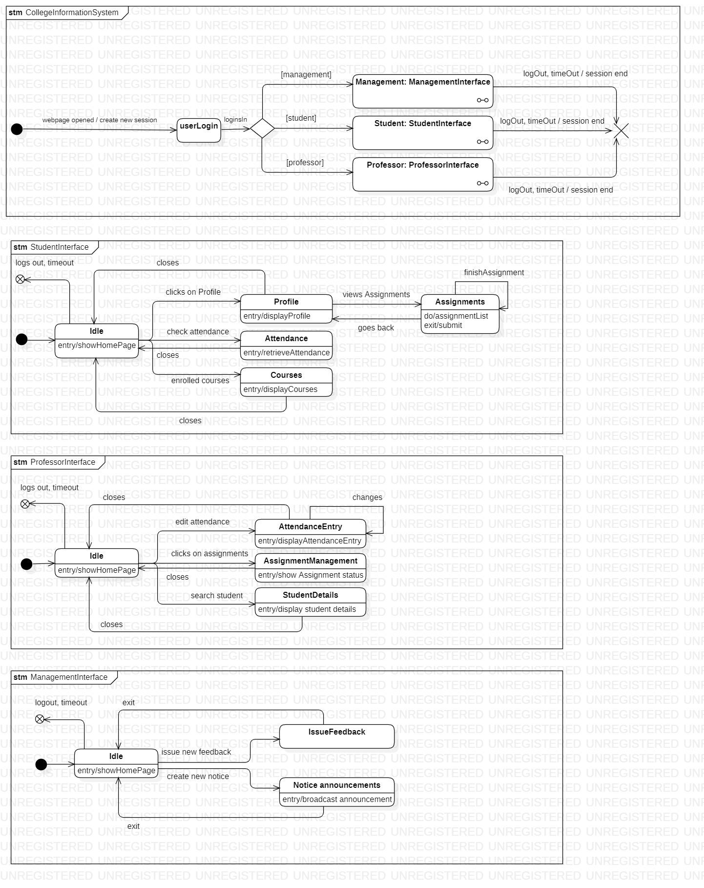

In the above state model, three expanded states are used to separately show the functionality of the different types of interfaces ,i.e., Management Interface, Student Interface, Professor Interface.

**2. HOSTEL MANAGEMENT SYSTEM:**

Advance Class Diagram: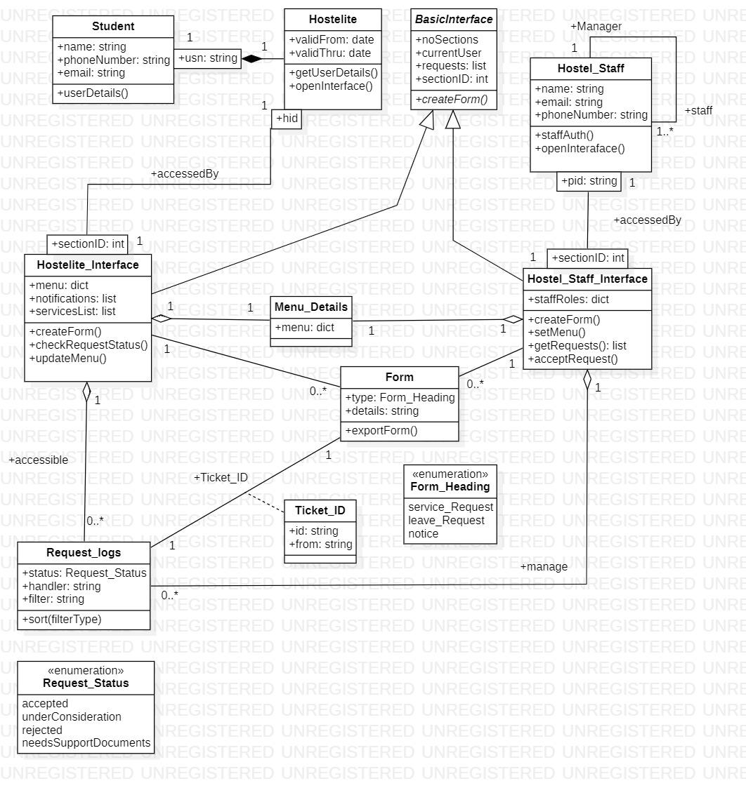

The above class diagram has qualified association to separately identify student who then has a composition to hostel. Hostel Interface and Hostel staff interface are generalized to Interfaces.

Advance State Diagram :

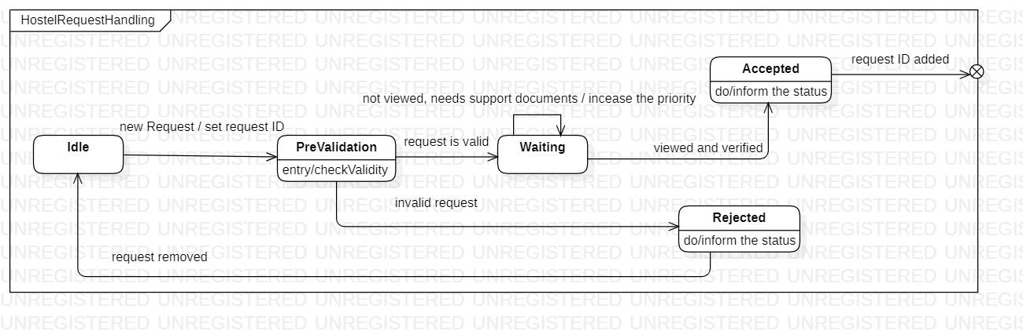

In the above state diagram, the scenario used is when a student applies for the hostel and how that request is being handled. When the system is Idle, it goes to Validation state which then is either accepted or rejected.

**3. STOCK MANAGEMENT SYSTEM:**

Advance Class Diagram:

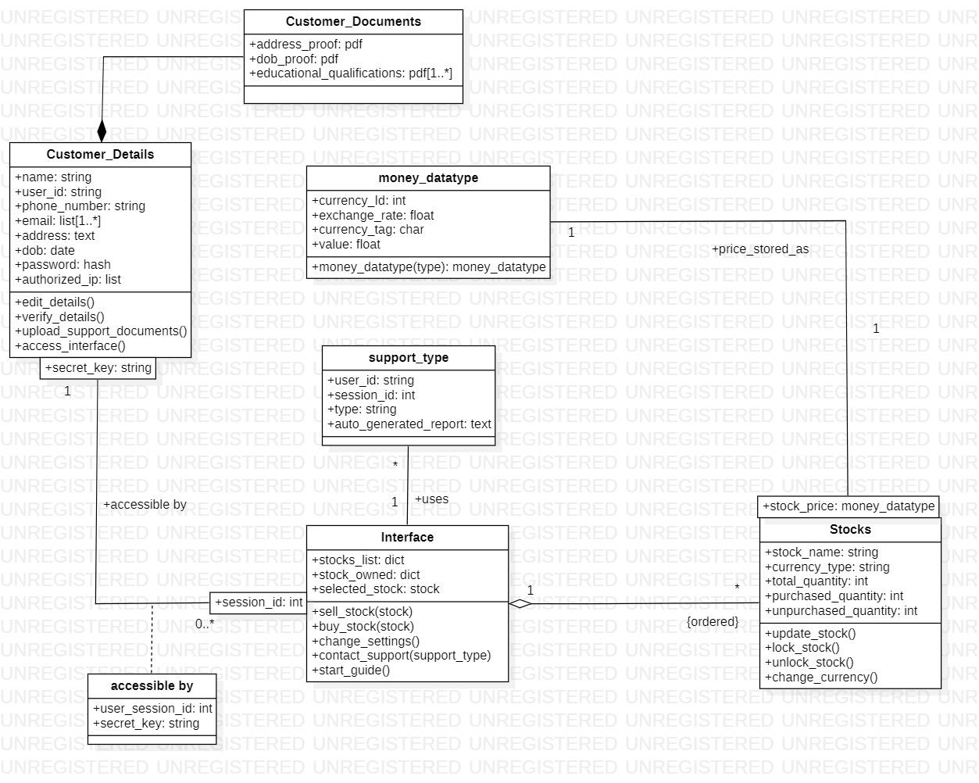

In the above class diagram, every interface can be identified by its session id as a qualified association is used. Customer details have a composition relationship with Customer Documents as if there are no customer documents then there can't be customer details.

Advance State Diagram:

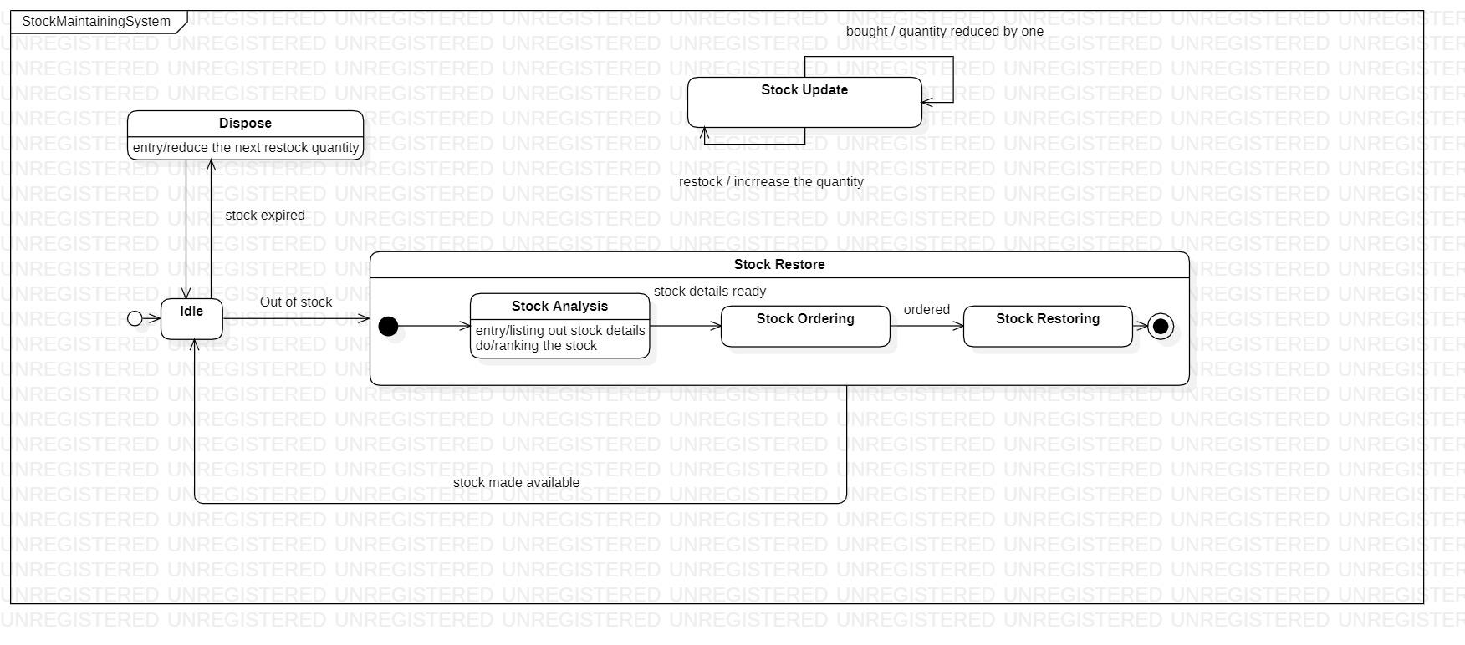

The scenario used here is maintaining the stock. Nested state is used in the above state diagram to show the complete process of stock restore when they are out of stocks. A separate state stock update is also shown.

**4. COFFEE VENDING MACHINE:**

Advance Class Diagram: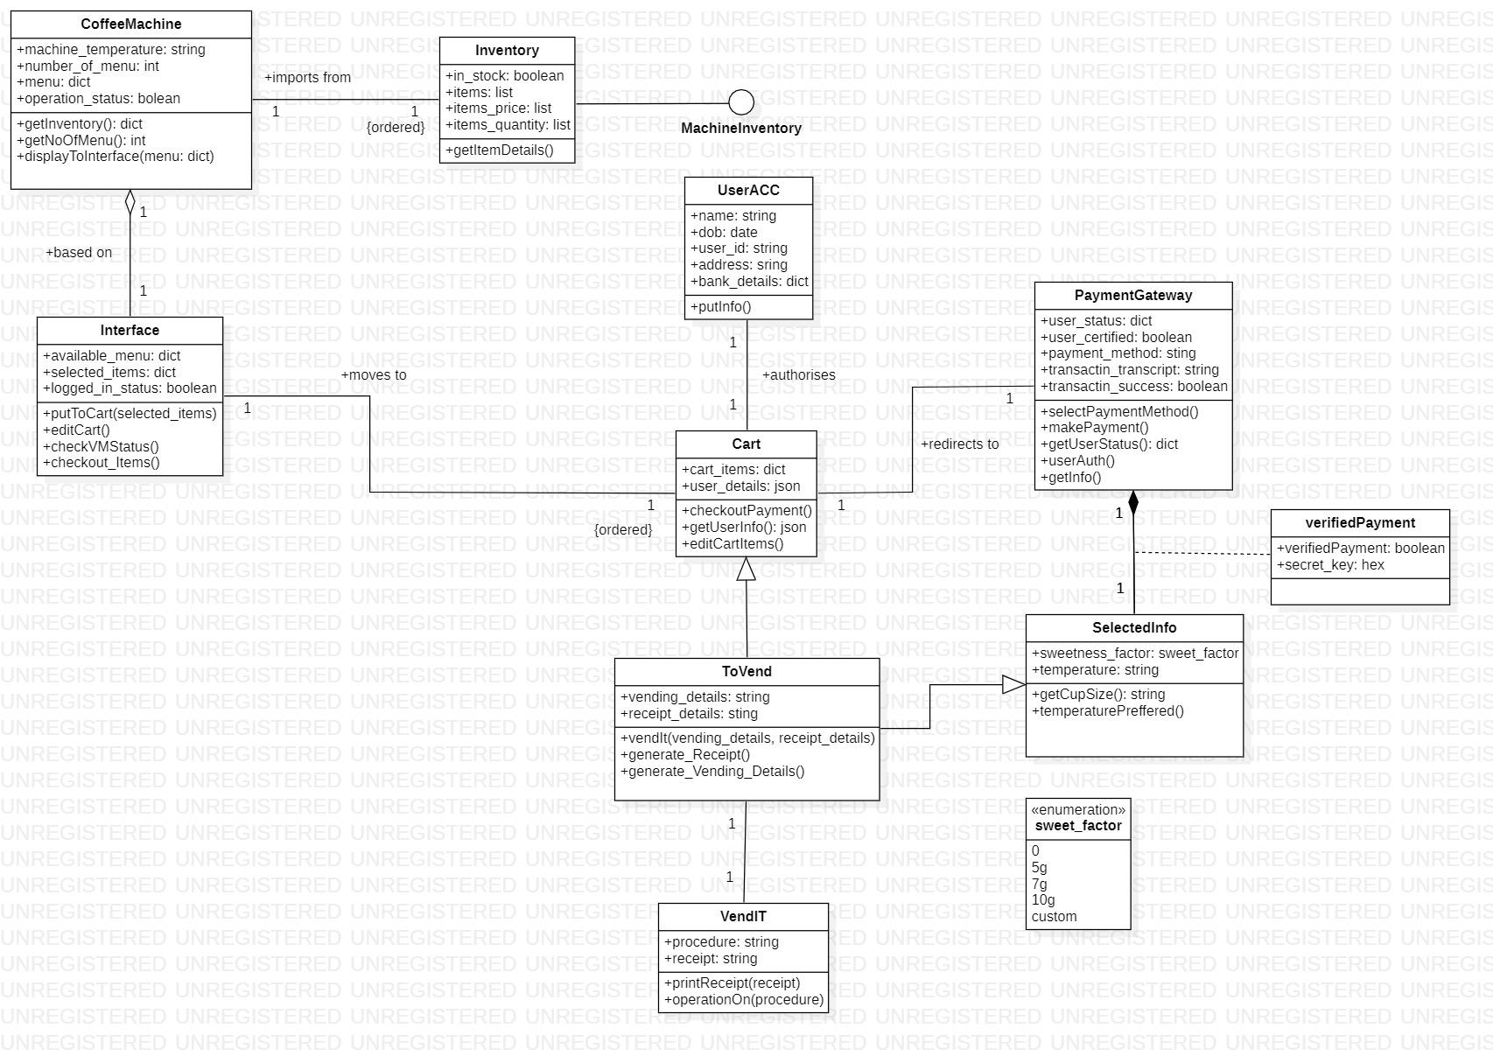

In the above class diagram, there is a state of machine inventory and a composition between payment gateway and selected info. Generalizations are also used between different states. Enumeration is also used to describe the sweet factor which is used as an attribute in selected info.

Advance State Diagram: 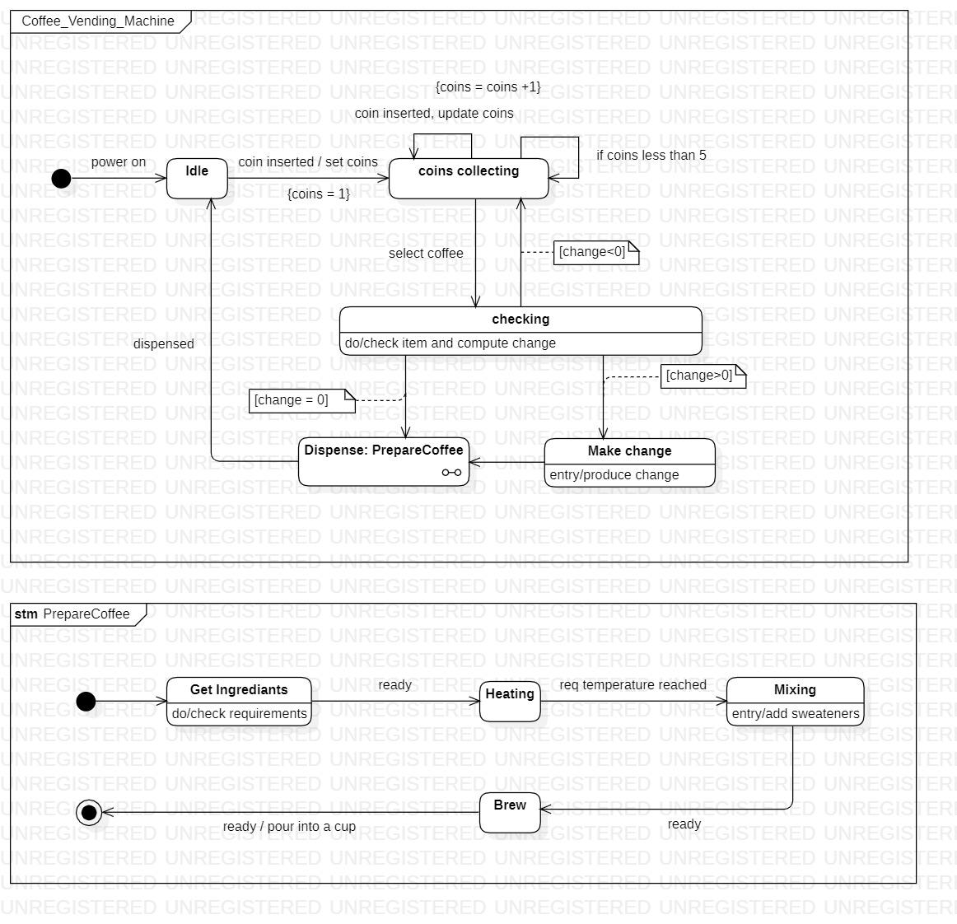

In the above state diagram, the process of payment and coffee making is shown. Coffee making state is shown in an expanded state while the payment process is shown in the main state diagram with states such as make changes, coin collecting etc.

**5. ONLINE SHOPPING SYSTEM:**

Advance Class Diagram: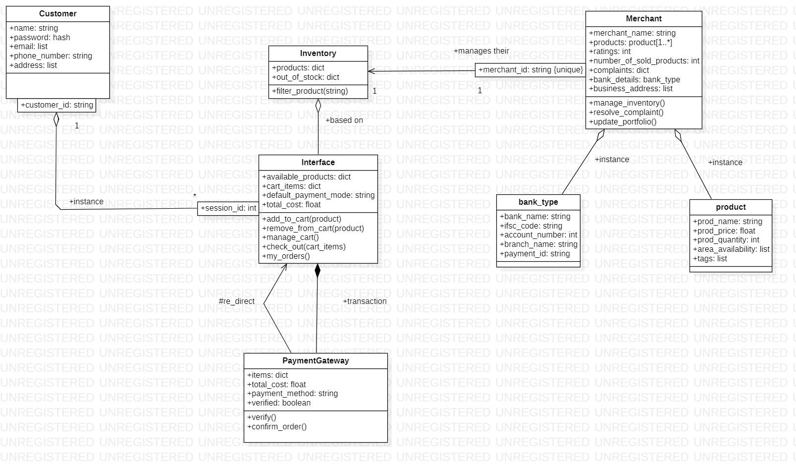

The online shopping system has customers who must have an account in the online website where he/she can purchase products.If customer wants to buy the product then he/she must be registered, unregistered user can’t go to the shopping cart.Customer login to the system by entering valid user id and password for the shopping. The products sold for customers are sold for various categories like men,women,kids and home products.After the payment or surf the product the customer will be logged out.

Advance State Diagram:

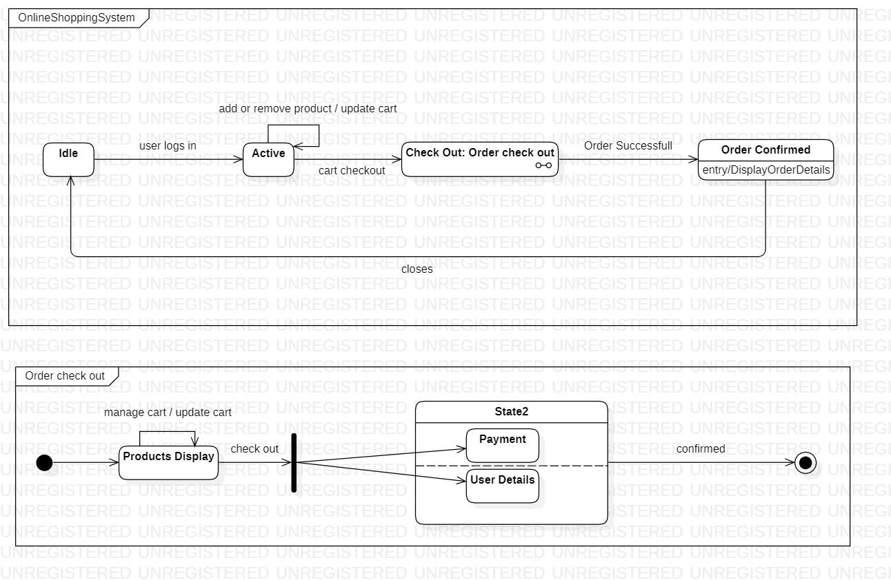

The advanced state chart diagram has states explaining the product purchase and payment. It has a sub machine, checkout product. Checkout product has states explaining the payment methods and validating the methods.

**6. RAILWAY RESERVATION SYSTEM:**

Advance Class Diagram: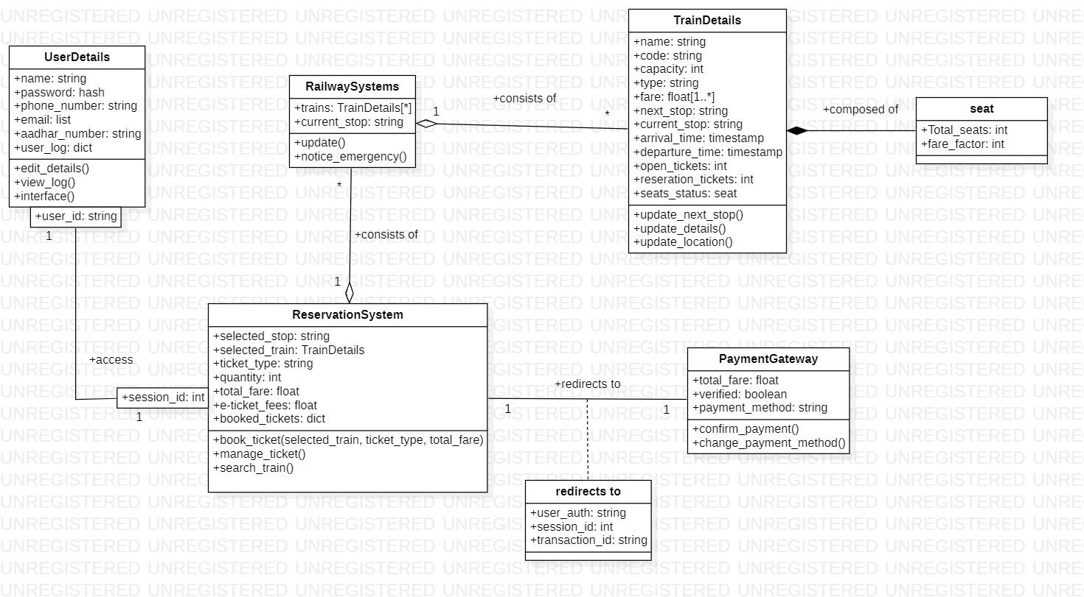

The admin manages the trains and reservations related to the railway reservation system. There Are Three types of reservation, I.e RAC,waiting and confirmed.The passengers with a reservation goes to one or the other reservation.A train consists of coaches and engines. Passenger pays for the ticket booked .Tickets can be booked in two ways by i-ticket or by e-ticket booking.

Advance State Diagram :

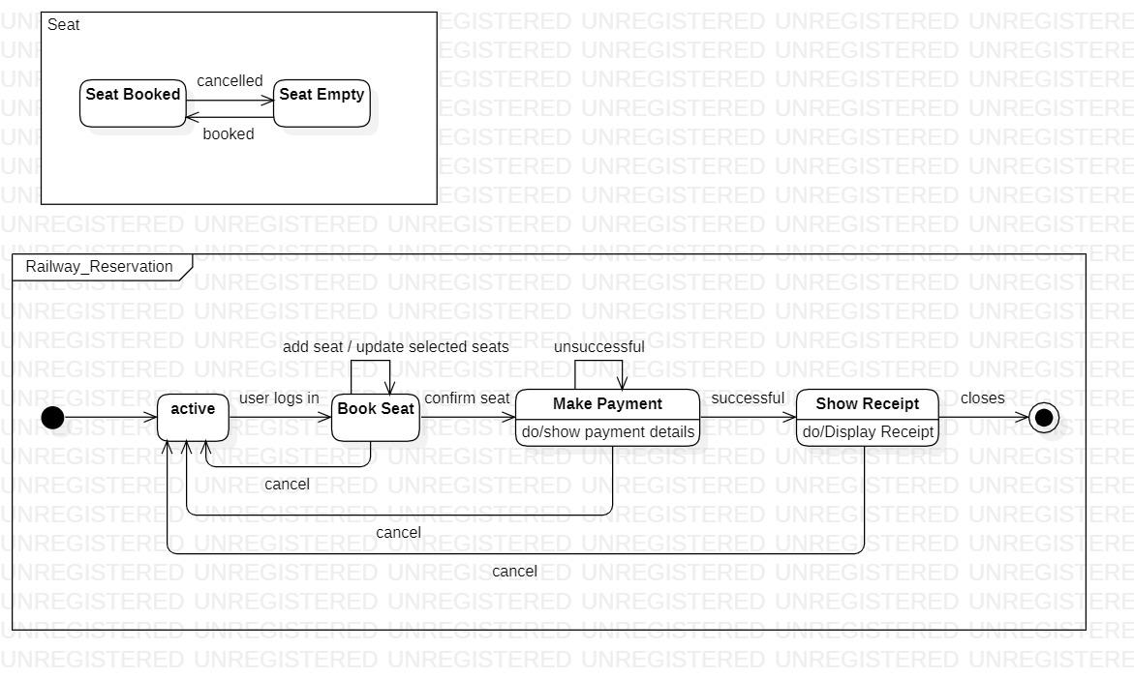

The advanced state diagram has states for paying the ticket.from the ready state the user goes payment initiation after which the card details are accepted and an OTP is sent to the registered mobile number. On verification the money is deducted and a ticket is sent to the customer. There is substrate machine for seat to show whether the seat is booked or empty.

**7. GRAPHICS EDITOR SYSTEM:**

Advance Class Diagram:

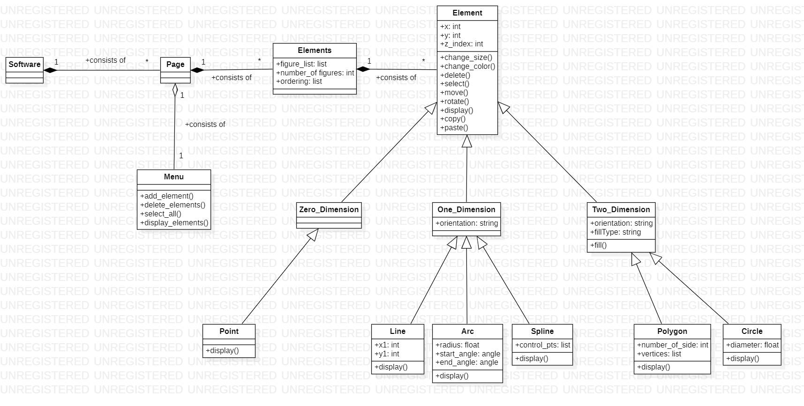

The graphical editor has pages consisting of several elements. Each element contains drawingobjects, including text, geometrical objects and groups. A group is simply a set of drawingobjects. A geometrical object includes circle, ellipse, rectangles, lines and squares.

Advance State Diagram:

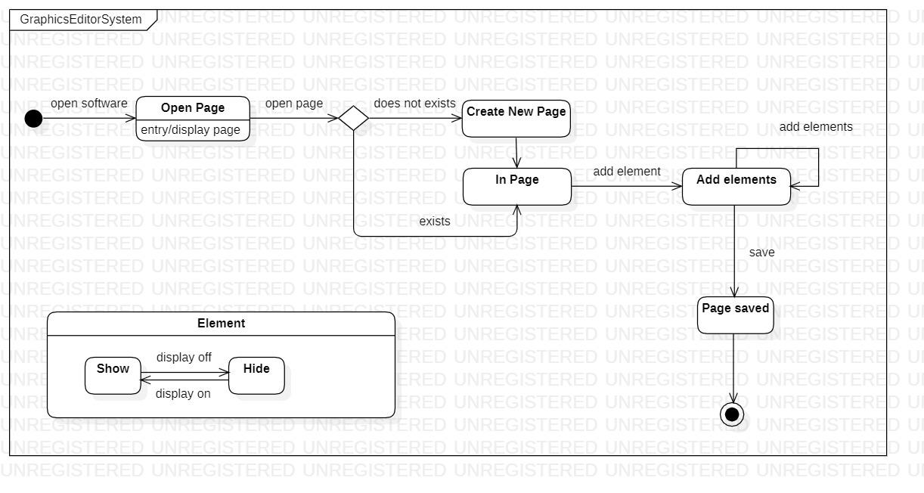

The above state diagram shows a scenario where the user can either create a new page or can use the existing page. In both the cases user can add elements and then once on completion, the user can save it.